United Nations Development Programme

Report on TRAC3 Allocation
For submission to CB upon project completion
(max 3 pages)

- Project Information
- Country: Jamaica
- Project/Initiative Title: Hurricane Preparedness Support Mechanism/ Jamaica Resilient Recovery Mechanism
- Focal point/Project Manager: Stacy-Ann Tomlinson-Knox
- Implementing Partners: UNDP
- Project Period (dd/mm/yy to dd/mm/yy): November 2025 – May 2026
- Beneficiaries/Government entities supported, including Number of Direct and Indirect Beneficiaries (as applicable):
- Budget allocation and utilization (USD):
Fund Code | Allocation | Utilization | Remaining balance (%)
4120 | N/A | N/A | N/A
4130 | $300,000.00 | $300,000.00 | 0.00
Total | $300,000.00 | $300,000.00 | 0.00

- Achievements based on the work plan (describe activities carried out and achievements, including innovative solutions/tools applied in coordination, assessment and recovery programming efforts)

Output/Activity | Status of Completion/fund utilization | Achievements  Output Indicators/Targets Achieved
Output 1: Safely demolished, removed and managed debris in line with environmental standards and the support of roofing facilities to vulnerable households | Completed/ $100,000 (100%  USD Utilization) | The utilization of data from the RAPIDA allowed for efficient identification and quantification of debris in impacted communities post Hurricane Melissa with an estimated 4.8 million tonnes produced. This data informed the Government of Jamaica’s approach to recovery.  Result 1: Cash for Work & Capacity Strengthening:  There were tangible improvements in environmental and health conditions of two impacted communities post Hurricane Melissa. Specifically, 890 tonnes (39 truckloads) of debris was removed via cash for work employing 58 community members (36 women and 22 men). Income earned through cash-for-work enabled participants to meet immediate household needs, reinvest in small livelihood activities, and contribute to community recovery efforts.  To ensure compliance with relevant environmental standards the capacity of the community members were strengthened in debris identification and separation, occupational health and safety, safe handling of hazardous materials, proper use of tools and personal protective equipment, environmental safeguards, recycling and reuse practices. The high proportion of women trained (62%) reflects deliberate efforts to promote women’s participation in non-traditional recovery roles and paid community work.  Result 2: Cash for Care:  Complementing cash-for-work, the Cash-for-Care component addressed care burdens exacerbated by the disaster, particularly for households with elderly persons and persons with disabilities. The economic resilience of seven women caregivers from within the affected communities was strengthened allowing for the provision of structured care and companionship services. As a result, 44 vulnerable households (24 in Savanna‑la‑Mar and 20 in Salt Spring) had improved wellbeing, reduced isolation, and enabling other household members; especially women, to reallocate time toward income generation or recovery-related tasks. The intervention demonstrated the value of recognizing and remunerating care work as a critical element of recovery while creating paid opportunities for women within their communities.
Output 2: Economic resilience of MSMEs owned by women and other vulnerable groups impacted by the crisis strengthened to recover and be more sustainable and resilient  Activity 2.1. Immediate livelihood and cash-based intervention with most vulnerable groups | In progress/ $96,500 (100%  USD Utilization) | Result 1: Livelihoods  The business operations of twenty-six (26) female entrepreneurs impacted by Hurricane Melissa were restored through targeted livelihood recovery inputs. Of the 26 beneficiaries supported, 21 were female-headed households (FHHs), while 6 were women living with disabilities, including blind women and one woman with multiple disabilities. This intersectional targeting ensured assistance reached women experiencing compounded vulnerabilities linked to gender, disability, rural location, age, and single parenthood.  Additionally, twenty-six (26) women-led micro and small enterprises resumed income-generating activities and community-level service delivery following the provision of tailored livelihood inputs. Enterprises supported included poultry farming, crop production, pig and goat rearing, agro-processing, retail shops, and restaurants.  Overall:  - 11 beneficiaries received chickens and poultry feed to replace flocks lost due to coop destruction and flooding.  - 1 beneficiary received pig replacement support following livestock loss.  - 1 beneficiary received materials to restore goat rearing operations.  - 10 beneficiaries received crop recovery inputs, including seedlings, fertilisers, pesticides, and farming tools to replant vegetables and short-term crops that were destroyed.  - Other beneficiaries received enterprise inputs such as business equipment and production supplies to restore shops, restaurant and agro-processing operations.  This support enabled women to restart production cycles, stabilise household income streams, and restore the flow of essential goods and services within their communities, directly contributing to localised economic recovery and food security.  Livelihood restoration in the poultry subsector was particularly significant, with 11 small-scale women farmers re-entering poultry production after experiencing losses ranging from dozens to over 100 birds per enterprise. Similarly, crop farmers re-established cultivation across vegetables and short-term crops that had suffered total loss. The replacement of productive assets has reduced prolonged income gaps and strengthened resilience among rural women farmers and female-headed households.  The business operations of 72 MSMEs and individuals in the agricultural and fisheries value chain impacted by Hurricane Melissa was restored through support provided to the agricultural and fisheries value chain. Specifically,  24 micro, small, and medium-sized enterprises (MSMEs) were enabled to restore their livelihoods and local service provision. Supported enterprises spanned food services, poultry farming, dressmaking, cosmetology, retail, and creative services. Inputs included equipment, appliances, tools, consumables, and raw materials tailored to each business’s needs. This support enabled entrepreneurs to resume operations, generate income, and re-establish essential goods and services within their communities, contributing to local economic recovery and multiplier effects.  22 poultry farmers’ ability to resume poultry production was enhanced through the provision of 2,050 baby chicks and 176 bags of feed. Similarly, honey production was bolstered through the provision 16 bee colonies to 10 beneficiaries supporting income diversification and climate-resilient livelihoods.  In the fisheries sector, the economic resilience of approximately 50 community members impacted by hurricane and related fire damages was enhanced through the procurement of two commercial Yamaha outboard motors (boat engines). This approach represents a scalable model for inclusive and resilient fisheries recovery.  The project is on track to support additional agricultural production and income generation through (1) the distribution of drip irrigation systems to 15 beneficiaries, covering one-quarter acre per recipient (2) provision if 10 pigs and 36 units of pig feed to 6 beneficiaries. Remaining enterprise inputs, including building materials, water tanks, and additional irrigation kits; were scheduled for phased delivery across target parishes.  In addition to material support, the project is on track to deliver an Empowerment and Capacity-Building Workshop for all 26 beneficiaries. This engagement will go beyond technical training to intentionally support trauma recovery and confidence rebuilding. Through facilitated dialogue and practical sessions on business continuity planning, financial stabilisation, stress and trauma management, and strategic growth planning, women will be equipped to process the psychological impacts of livelihood loss and to strengthen their capacity to “build back better”. The workshop is designed to reinforce agency, resilience, and long-term enterprise sustainability, positioning beneficiaries to transition from recovery toward sustained economic empowerment.  Complementing material support, psychosocial and capacity-building interventions were delivered to address the non-economic dimensions of recovery. Beneficiaries participated in structured sessions on mental health and stress management, conflict resolution, and disaster risk management. These interventions strengthened coping mechanisms, supported emotional recovery, and enhanced beneficiaries’ capacity to manage future shocks. The integration of psychosocial support alongside livelihood inputs reinforced a holistic recovery approach, recognizing that sustainable resilience requires both economic stabilization and mental well-being.
Output 3: Solar solutions for re-energizing communities  Activity 3: Site selection and deployment of solar systems to restore energy access in critical community and public facilities. | Completed/ $60,000.00 (100% Utilization) | Access to clean energy was restored to three hurricane-affected fisheries communities benefitting approximately 280 fishers through the commissioning of resilient solar recovery solutions. Notably, the deployment of two containerized systems resulted in a reduction in post-harvest loss through the provide cold storage for fish preservation thus preventing, secure equipment storage, power supply for daily operations, and reliable internet connectivity to support coordination and communication. Additionally, the installation of the roof-top solar panels enabled operational continuity through the provision of cold storage.

SURGE Mission

During the reporting period, the UNDP Jamaica Multi‑Country Office (MCO) received two SURGE missions to strengthen the formulation and strategic positioning of Jamaica’s resilient recovery efforts. The SURGE team facilitated strategic engagement with key stakeholders including Government counterparts, private sector and impacted communities to identify emerging priorities and articulate UNDP’s long-term resilient recovery offer.
The SURGE missions also supported field‑based engagement and technical backstopping, including site visits to hurricane‑affected communities, analytical inputs to recovery planning, and hands‑on support for resource mobilization. SURGE specialists also provided technical advisory support to the Government of Jamaica in coordinating initial Damage & Loss Assessments, with specific focus on Human Impact & Risk Analysis. Through these efforts, the missions strengthened the evidence base for resilient recovery programming, informed the design of integrated interventions across livelihoods, infrastructure, and social resilience, and reinforced institutional coordination for a resilient recovery approach. Collectively, the SURGE support enhanced the MCO’s capacity to translate early recovery insights into scalable, resilient recovery programming grounded in national ownership and informed by global best practice.
Relief Items
In the aftermath of Hurricane Melissa, the UNDP Jamaica Multi‑Country Office received a range of in‑kind relief and recovery items from the UNDP Regional Hub at no cost. This support was mobilized to strengthen early recovery efforts and to bolster resilient recovery interventions in communities most impacted by the hurricane, particularly in support of debris clearance, restoration of basic services, and the safe resumption of livelihoods.
The items received included essential tools and equipment such as chainsaws, shovels, rakes, machetes, wheelbarrows, and generators, as well as personal protective equipment (PPE) to support safe operations. PPE items comprised gloves, high‑visibility vests, protective boots, hard hats, and protective eyewear, among others. These resources have been instrumental in enabling safe and effective community‑level recovery activities. The full inventory of items received is detailed in the Annex 1 below.

Hurricane Preparedness Support Mechanism
During the reporting period, the business continuity planning (BCP) capacities of 19 female MSME owners were strengthened through targeted BCP training. Participants enhanced their ability to anticipate, prepare for, respond to, and recover from climate‑related shocks, particularly hurricanes.
The BCP training equipped participants with practical knowledge and tools to identify business risks, protect critical assets, and develop continuity strategies that reduce downtime and financial losses during emergencies. As a result, women‑led MSMEs are better positioned to safeguard livelihoods, maintain operations during disruptions, and contribute to greater economic stability within their communities. The training also supported improved decision‑making, increased confidence in crisis preparedness, and strengthened long‑term business resilience.
Additionally, a total of 35 Resilience Kits were distributed to participants of the BCP training, directly supporting practical hurricane preparedness and business continuity efforts. Each kit included essential preparedness tools, such as solar lanterns, power banks, first aid kits, and waterproof document holders to secure important business and personal documents.
These resources enhance participants’ capacity to maintain basic operations, ensure personal safety, and protect critical records during and after extreme weather events. The distribution of Resilience Kits reinforced the application of BCP knowledge and translated training outcomes into tangible, immediate resilience support.
Funds originally allocated for Cohort 2 of the BCP training were repurposed to address the urgent needs of impacted individuals. Through this reallocation, care packages were distributed to over 40 affected persons, prioritising women-led households and individuals facing heightened post-disaster hardship. The care packages included essential food and household supplies, providing immediate relief while beneficiaries worked to restore their livelihoods. This adaptive approach ensured that resources remained responsive to evolving community needs, balancing longer-term resilience-building objectives with urgent social protection support during the recovery phase.
Finally, UNDP successfully convened its in‑person and virtual Resilience Series, focused on key challenges and issues impacting MSMEs across the territories covered by the Multi‑Country Office. The series brought together local and regional stakeholders, fostering dialogue on shared constraints facing MSMEs, including vulnerability to climate shocks and systemic operational challenges.
Through these engagements, stakeholders collectively proposed tactical and actionable steps to improve the current realities of MSMEs in Jamaica. The Resilience Series strengthened collaboration, knowledge exchange, and coordinated approaches to MSME resilience, while amplifying locally grounded and regionally informed solutions.

- Gender responsive programming (describe how the CO responded to the gender differential impact of the crisis, noting the requirement of a GEN 3 Output with 15% of budget allocation)

The recovery interventions were intentionally designed and implemented through a gender‑responsive lens, ensuring equitable access to benefits for women, men, elderly persons, and persons with disabilities, in line with UNDP’s GEN 3 crisis‑response requirements. Within the debris‑removal and recovery activities, beneficiary selection criteria prioritized women‑headed households and other vulnerable groups from the outset. Training curricula incorporated occupational safety, responsible conduct, hazard identification, and proper use of personal protective equipment, enabling women to participate confidently and safely in recovery tasks traditionally dominated by men. Recognizing gender‑differentiated recovery burdens; particularly women’s disproportionate unpaid care responsibilities, the intervention deliberately integrated cash‑for‑care roles alongside physically intensive debris‑removal activities, creating flexible and dignified income‑earning opportunities for women, elderly participants, and individuals unable to engage in heavy labour. This inclusive design both diversified participation and strengthened community cohesion by ensuring that care‑dependent residents received essential support during the recovery phase.

Gender responsiveness was also included within the livelihood support component by prioritising the restoration of women’s livelihoods, particularly female-headed households and women with disabilities who faced compounded economic and social vulnerabilities. Through targeted and intersectional beneficiary selection, the Country Office ensured that recovery resources were directed to women whose productive and reproductive roles had been most disrupted by the crisis. Tailored livelihood inputs enabled women-led micro and small enterprises to resume income-generating activities.

By restoring productive assets and enterprise operations, the intervention directly addressed women’s disproportionate care burdens and income losses, stabilised household earnings, strengthened food security, and reinforced the economic agency and resilience of female-headed households within affected rural communities. Importantly, by safeguarding women’s control over productive resources and income streams, the intervention contributed to reducing gender inequality in access to assets and economic opportunities, strengthening women’s decision-making power within households and communities, and advancing their longer-term economic empowerment and participation in local recovery processes.

Gender responsiveness was also embedded within the renewable energy intervention, which aimed to re‑energize communities and protect livelihoods through resilient infrastructure solutions. Site selection and implementation explicitly considered the differentiated economic impacts of Hurricane Melissa, particularly on women engaged across value chains. The Rio de Nuevo Fishing Association in St. Mary; a women‑led fishing association was prioritized for rooftop solar installation, directly supporting approximately 30 fishers while strengthening women’s leadership in local economic recovery. By restoring reliable electricity for cold storage, processing, and daily operations, the intervention helped safeguard income‑generating activities in a sector where women are frequently concentrated in post‑harvest handling, sales, and cooperative management. The integration of renewable energy solutions and Starlink connectivity enhanced not only energy resilience but also digital access, enabling women’s participation in coordination, communication, and market engagement, and reinforcing their role as key actors in resilient and inclusive recovery.

- Partnerships and Resource Mobilization (briefly describe key partnerships built/strengthened, including work with actors across the HDP-nexus and key resource mobilization efforts the CO has made to respond to the crisis)

To advance debris removal and livelihood recovery efforts, the UNDP partnered with various CSOs including Project STAR, Jamaica 4-H Club and the Jamaica Network for Rural Women's Producers. These organizations were selected due to their existing networks within those impacted communities which therefore facilitated easier engagement. It should be noted that the latter two organizations had existing partnerships with UNDP which were bolstered to assist those networks that were being strengthened previously.

The UNDP Country Office successfully mobilized USD 500,000 from the CARICOM Development Fund to deepen and widen debris management and clearance operations across affected communities, ensuring faster environmental recovery and safer living conditions. Complementing this, the Australian High Commission contributed approximately USD 60,000 to support the expansion of renewable energy solutions, enabling the integration of resilient, low‑carbon technologies within community facilities and MSME recovery efforts. Complementarily, the MCO accessed USD 717,000 from the ongoing ACP-EU Strengthening Disaster Risk Governance and Recovery Capacities global project. These resources will specifically support recovery needs assessments, resilient recovery planning and governance, and local community resilience via the establishment of technical assistance centres. Building on these achievements, the team is actively preparing a proposal to China International Development Cooperation Agency (CIDCA) to further strengthen renewable energy integration as part of long‑term resilience building. Collectively, these initiatives form the Jamaica Resilient Recovery Initiative (JARRI) project.

In parallel, UNDP is also working closely with the Government of Jamaica to prepare a major submission to the Fund for Responding to Loss and Damage, with the aim of mobilizing USD 20 million to advance national-scale resilience, recovery, and climate‑adaptive infrastructure solutions. Together, these efforts reflect a strategic, multi‑partner approach to leveraging international financing for community recovery, climate resilience, and sustainable development.

- Challenges and Lessons Learned (briefly describe challenges including results unachieved or progress off-track and lessons learned)

Implementation of the recovery interventions encountered a range of operational and contextual challenges typical of post-disaster environments, particularly related to accessibility, logistics, safety, and inclusion. In both target communities for debris removal, blocked roads, narrow lanes, and residual flooding constrained the movement of heavy equipment and waste, requiring teams to adapt by using smaller vehicles and, in some instances, manual transport methods. The nature of the debris; often comprising hazardous materials, heavy objects, and unstable structures, heightened occupational risks and necessitated strict enforcement of safety protocols, continuous supervision, and repeated refresher guidance on personal protective equipment (PPE) use. Additional complexity arose in ensuring that elderly persons and individuals with disabilities were not unintentionally excluded from recovery benefits, requiring tailored engagement approaches to balance safety considerations with equitable participation and access to care-support services.

Notably, due to the scale of devastation across impacted parishes, delays were experienced in acquiring specific enterprise-related materials as demand exceeded local supply. To mitigate disruptions, contingency measures were implemented to source required items from neighbouring parishes once stock was replenished, ensuring beneficiaries received the required inputs to fully restore operations.
Several key lessons emerged from addressing these challenges. First, early, detailed, and participatory assessments proved critical in shaping realistic implementation strategies, informing beneficiary selection, and ensuring that activities responded to differentiated household needs, particularly for those requiring care support rather than physical labour. Second, strong community engagement mechanisms, including close collaboration with Community Transformation Committees and civil society organizations, significantly improved verification, transparency, and day‑to‑day supervision, underscoring the value of leveraging trusted local actors for accountability and operational efficiency. The experience further reinforced the importance of integrating safety training and PPE distribution at the outset of implementation, as this reduced delays, strengthened compliance, and improved worker confidence in high‑risk environments. Overall, the project demonstrated that gender‑responsive and inclusive approaches enhance programme effectiveness, with high participation by women, accommodations for elderly persons, and inclusion of persons with disabilities contributing to stronger social cohesion and more equitable recovery outcomes. Importantly, community feedback confirmed that combining livelihood support with visible improvements to the physical environment helped restore dignity, hope, and psychosocial wellbeing, validating cash‑for‑work and cash‑for‑care modalities as effective tools for holistic recovery.

The renewable energy intervention similarly faced practical challenges linked to post‑disaster infrastructure damage and environmental conditions. In several locations, rooftop solar installations were not feasible due to compromised structural integrity, which would have required rehabilitation beyond the project’s scope and timeline. This constraint necessitated an adaptive approach, resulting in the deployment of prefabricated solar container hubs as stand‑alone, modular energy centres capable of rapid installation and independent operation. While effective, this shift required additional coordination related to site placement, ventilation, and technical configuration, as well as careful planning to ensure safe operation in coastal environments characterized by high humidity, salt exposure, and corrosion risks.

Asset security and long‑term sustainability also emerged as important considerations. The solar container hubs house high‑value components, including lithium battery systems, hybrid inverters, cold‑storage equipment, air‑conditioning units, and Starlink connectivity devices. In open coastal areas with limited secured infrastructure, safeguarding these assets required deliberate governance arrangements. To mitigate risks, keys and access responsibilities were formally entrusted to designated government representatives, complemented by the identification of trusted community members responsible for day‑to‑day monitoring and stewardship. This dual accountability model, combining institutional oversight with community custodianship, strengthened asset protection, enhanced local ownership, and reduced risks of misuse or theft.

Key lessons from the renewable energy intervention highlight that technical solutions alone are insufficient in crisis recovery contexts. Infrastructure resilience must be accompanied by governance, safety, maintenance planning, and community ownership mechanisms embedded from the outset. The experience demonstrated that modular, containerized solar solutions offer a highly adaptable and scalable model for rapid post‑disaster energy restoration, particularly where existing structures are compromised. Future recovery initiatives can build on this approach by formalizing maintenance responsibilities and stewardship agreements early in implementation, thereby strengthening sustainability, durability, and long‑term impact.

- URL links (include URL links to knowledge products, press releases, stories, pictures, videos, etc. produced by your CO in relation to this crisis response)

- https://www.youtube.com/watch?v=hyXAgFdFQ0o
- https://www.youtube.com/watch?v=ghKI-O8hacY
- https://www.fisheries.gov.jm/youth-livelihood-recovery-jamaica-undp/
- https://www.jamaicaobserver.com/2025/12/20/project-star-undp-launch-cash-work-initiative-savanna-la-mar-salt-spring/
- https://www.undp.org/press-releases/more-48-million-tonnes-debris-left-hurricane-melissa-across-western-jamaica-according-un-development-programme-analysis
- UNDP donates solar energy community centres to 2 hurricane-impacted fishing villages | United Nations Development Programme
- UNDP, Australia partner on $9m project to build three solar centres for hurricane-hot fishers | News | Jamaica Gleaner
- https://www.jamaicaobserver.com/2025/12/20/project-star-undp-launch-cash-work-initiative-savanna-la-mar-salt-spring/
- https://www.projectstarja.com/in-the-news/project-star-shows-the-way-forward

Annex 1

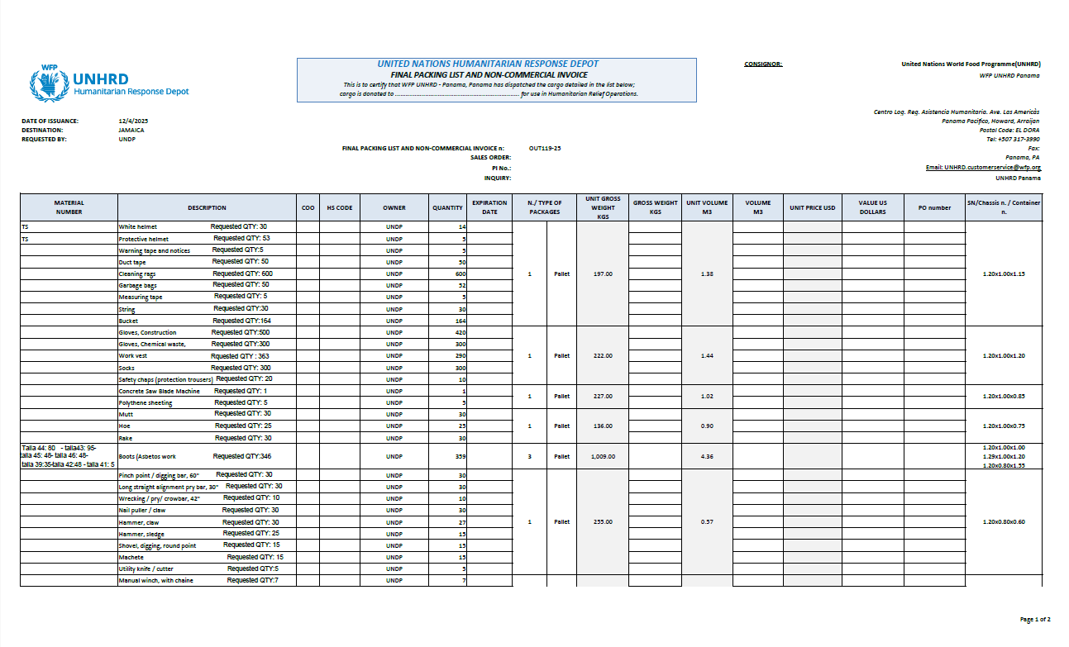

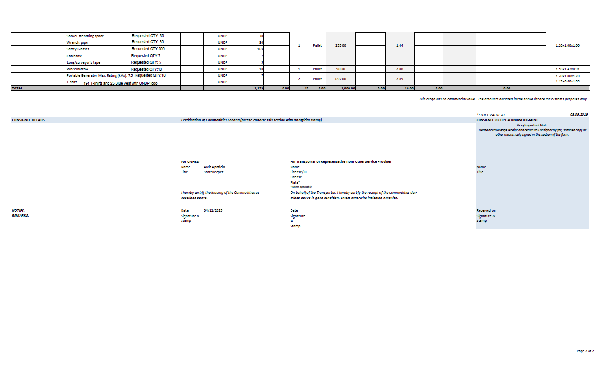

Over 200 in Parottee, more than 50 in Galleon, and approximately 30 in Rio de Nuevo
In Parottee and Galleon, two fully equipped solar-powered prefabricated container hubs were installed as modular energy centres to support fisheries recovery. Each 20x8 container was fitted with eight 700W photovoltaic panels, two 15kWh lithium-ion batteries, a 6kW hybrid inverter, split 110V and 220V outlets, a 24 BTU air conditioning unit, three 22 cubic foot chest freezers, and a Starlink Mini connectivity unit. In St. Mary, the Rio de Nuevo Fishing Association received a rooftop solar installation consisting of six 700W PV modules, a 10kWh lithium-ion phosphate smart battery, a 6kW hybrid inverter, and a Starlink Mini unit. This system restored electricity to the association’s facility, enabling cold storage, operational continuity, and digital connectivity for approximately 30 fishers

